1. Create a database named CDAC

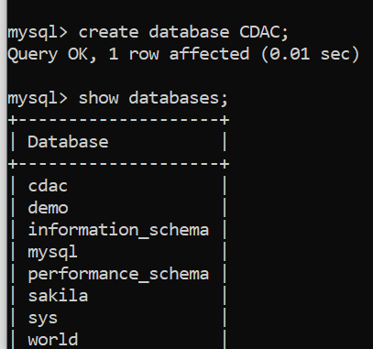

2.Create a table PGDAC in CDAC Roll_No int,name varchar(20),City varchar(20)

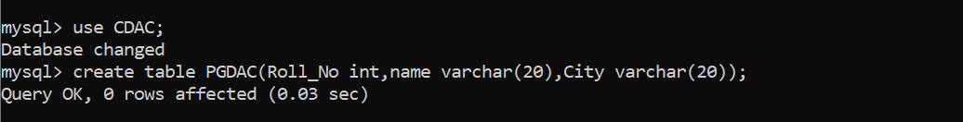

3.Insert details of 10 students in PGDAC

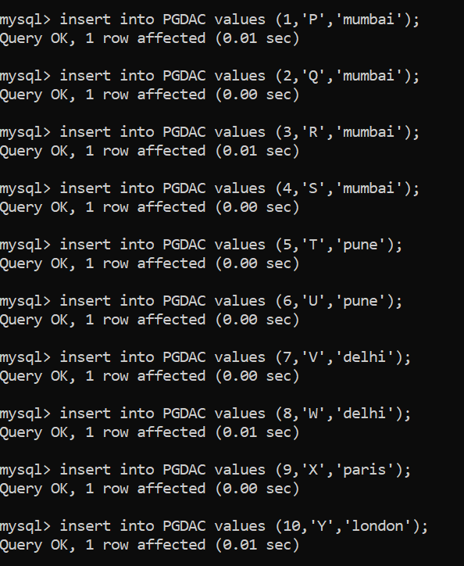

1. Display name of all the students

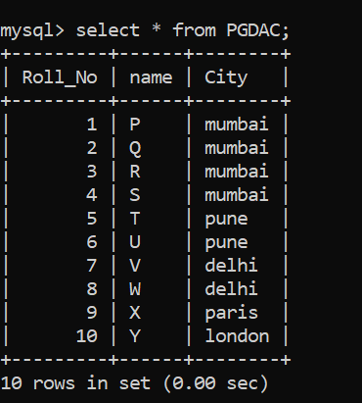

1. Display details of all the students



1. Display the structure of the table PGDAC

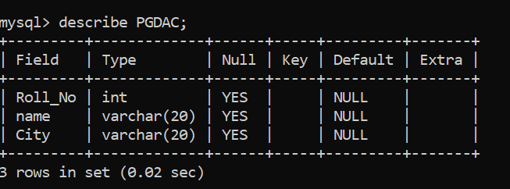



7.Create another table SUBJECT in CDAC Subject_code int,Subject_name varchar(50)

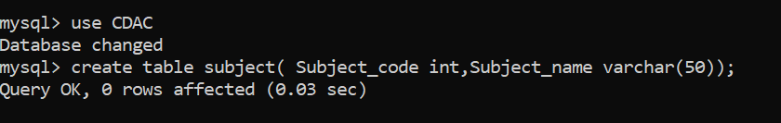

8. Insert some subject code and subject_name values in SUBJECT

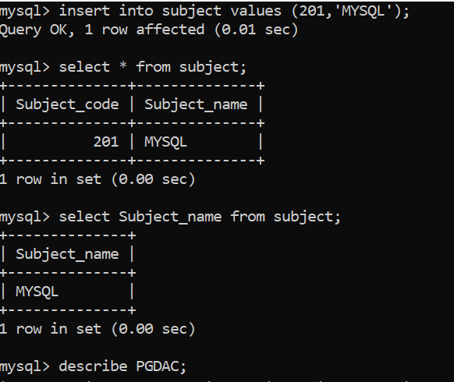

9. Display subject names from SUBJECT

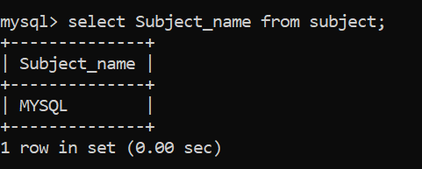

10. Display all records from the table SUB.

